# Aim

I want to create a website for parents of multiplies to connect to other parents. A website that shares the joys and struggles of being a parent of multiples, from tips to the fun, a place any parent can connect, understand and be heard. Made by mum for mum.

# User Persona

**Backgroud**: GINA, 30 years old, mum of twins, live in Dublin Ireland, Earned her degree in psychology and in a school before deciding to stay home with the 6months old twins.

**Interest:** outdoor activities, love reading/ researching new website to connect to other mums.

**Goals:** Meets another mum of multiple approximately the same age as her twins and on the same nap schedule, find more time to take care of herself, stop feeling guilty for the life she had before kids.

**Benefits of the site:** Friendship, joy and hardship of parenting twins.

**Background**: Rita, 25 years old, mum of a toddler aged 2 years and new born aged 4 months. She works part-time as a shop assistant and will return to work from her maternity leave in 5weeks.

**Goals:** Learn to cope with kids of different ages, giving attention to both kids equally

# Problem statement

* Letting all users know that parents are not vetted before access the site, if users choose to meet up with other parents, is at their own risk.
* Letting other parents know they are not alone in the struggles
* Links to fun activities in one place.

# Ideation

* Tip of parenting twins/ multiplies
* Twins/multiply pregnancy
* Breastfeeding
* Newborn (survival guide)
* motherhood
* Life before motherhood
* Sleep schedule
* Working parent’s
* Stay at home parents

# User needs.

* Parents will find a curated list of family/ child friendly activities taking place across the country gathered from different websites in one place for them.
* Letting other parents know they are not alone in the struggles.
* Parents will find a curated list of family/ child friendly activities taking place across the country gathered from different websites in one place for them.
* Fun activities and hacks for parents and children.
* Fun things to do outdoors with children.

# SiteMap

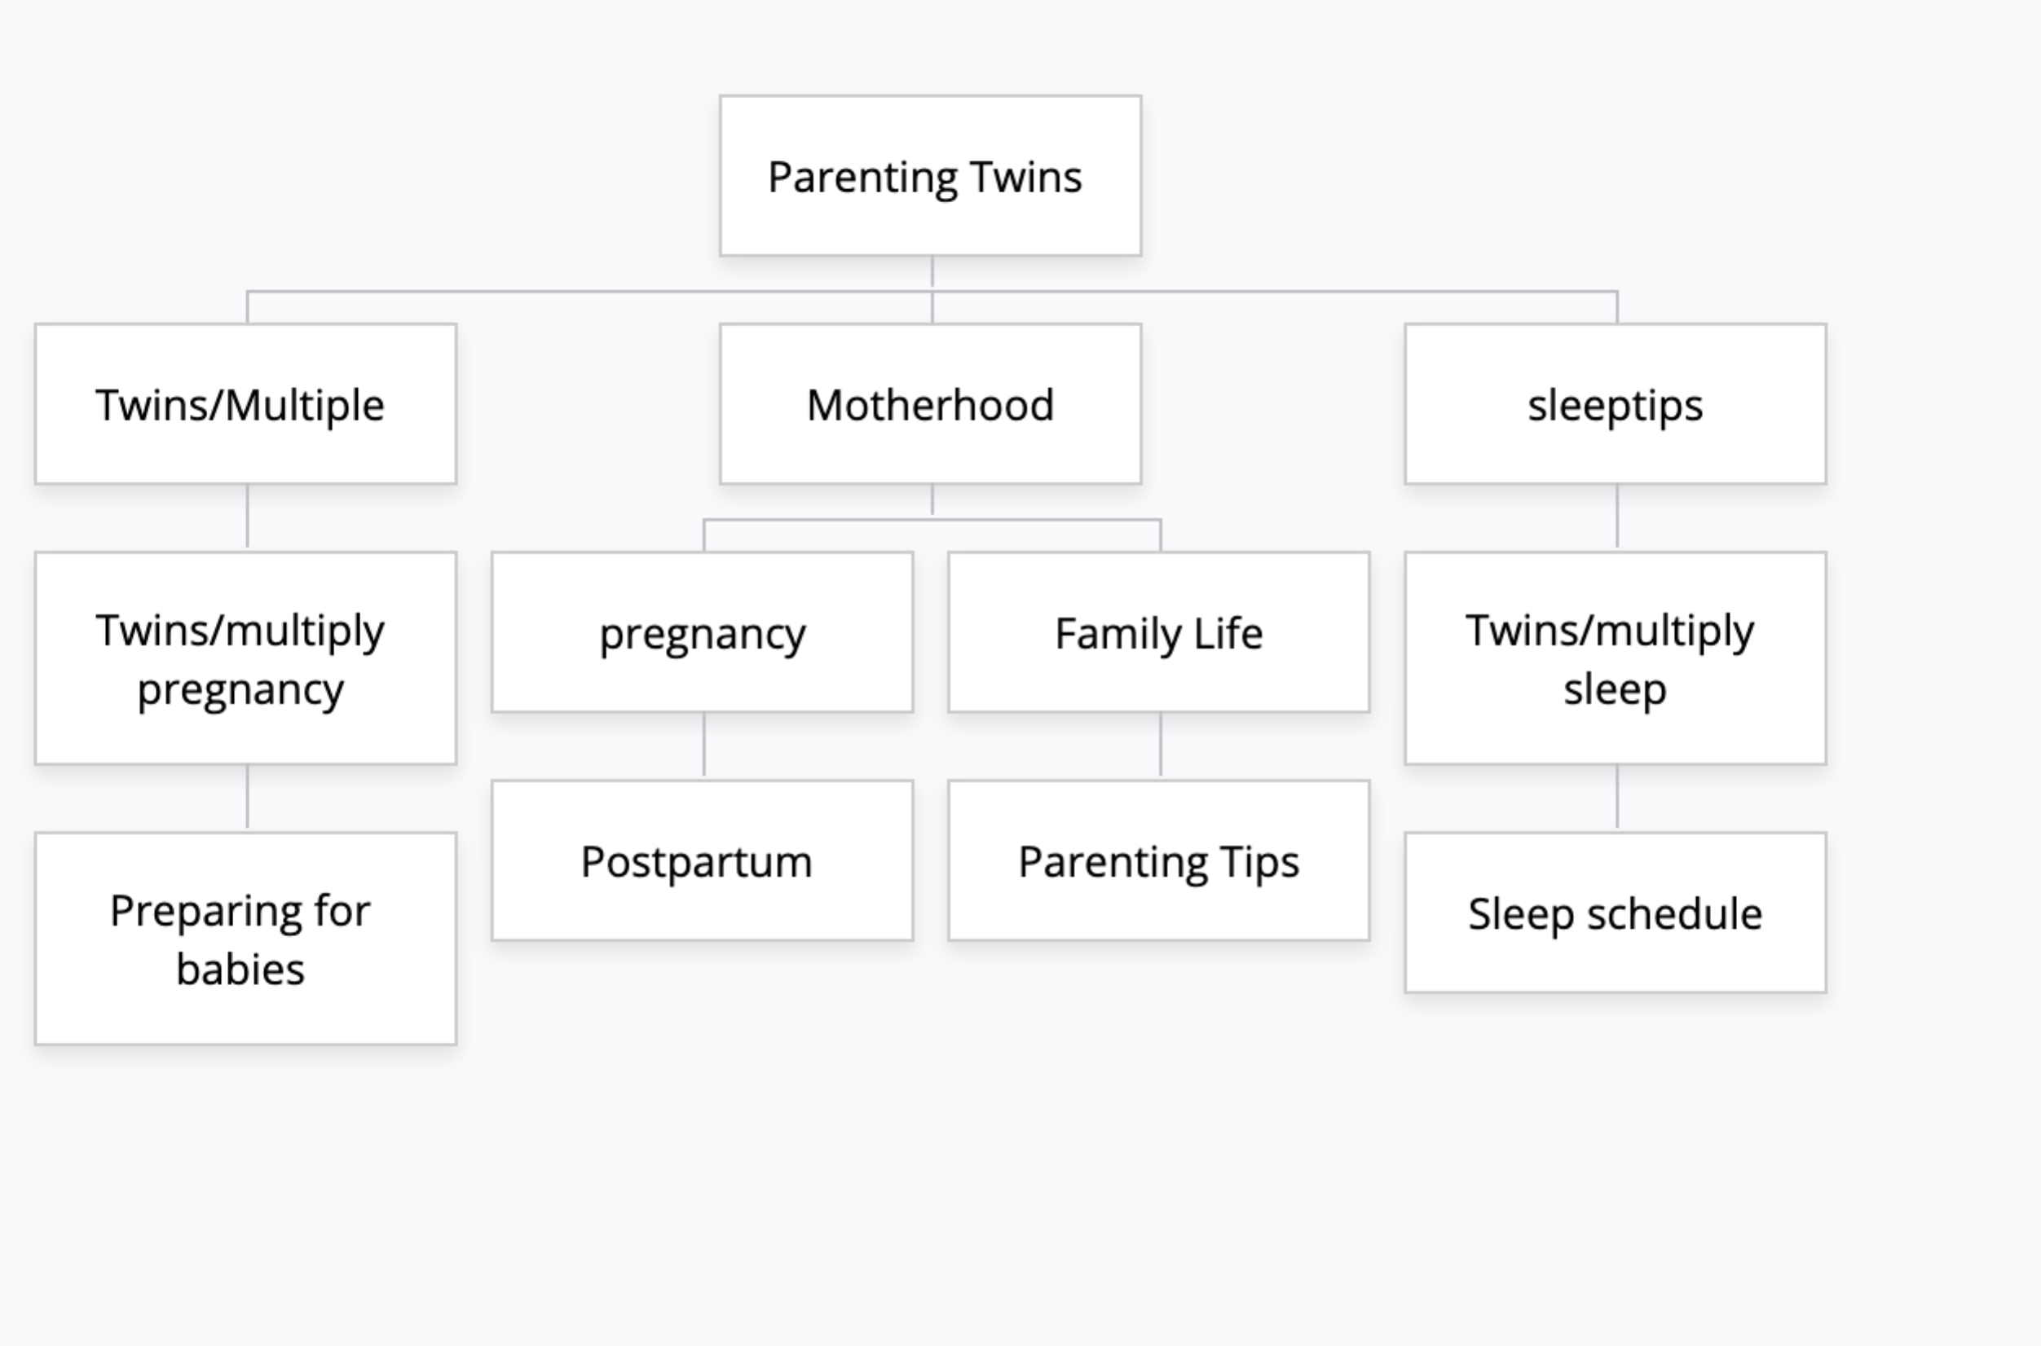

# Page Description

|  |  |
| --- | --- |
| Home | Items |
| Home | * Feature twins/multiply pregancy * Sleep schedules * Twins/ Multiply by stage * Resources * Onclick link to contact us |
| Contact Us | * Drop down meun * Submit contact form * Disply confirmation |
| About | * Drop down meun * About Twins/multiple Paranting * Contact us form * Blog * feedback |

# Mockup 1

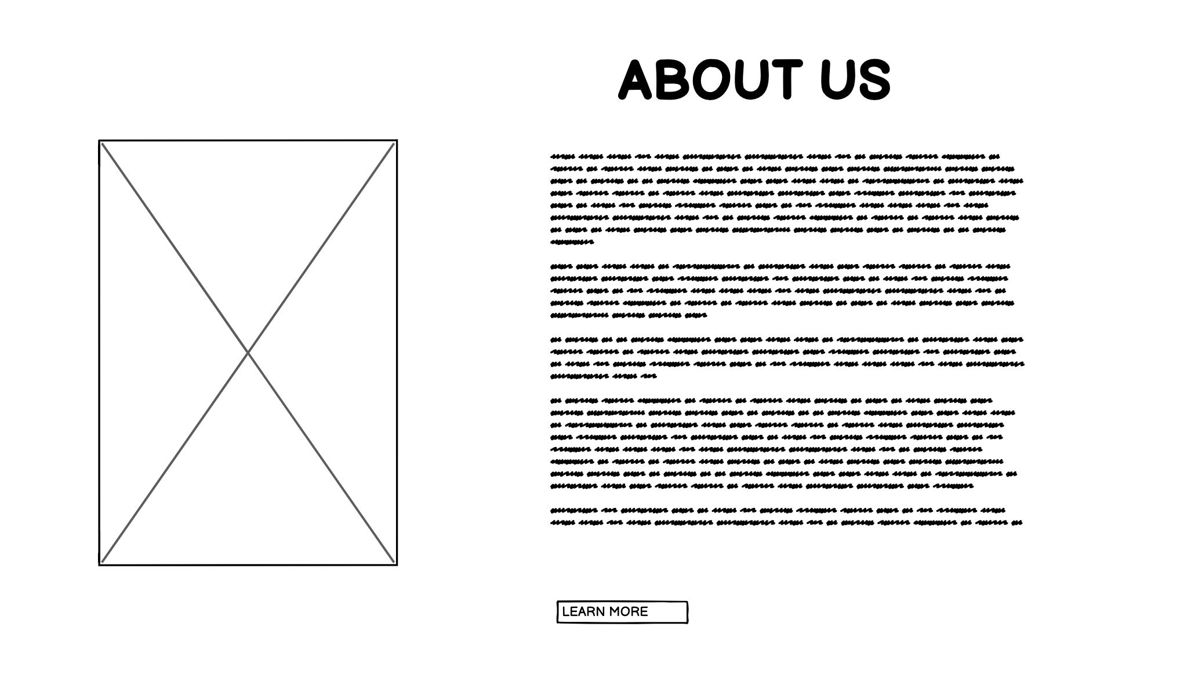

# Mockup 2

